Anomaly Detection in Daily Sales Data
Report on Exercises 1–3
Z-score • Modified Z-score (MAD) • KNN Distance-Based Detection

1. Introduction
This report summarizes the work completed on the daily sales anomaly-detection exercise. The dataset contains daily sales observations for four products (P001–P004) over roughly two years. The main goal was to understand how different anomaly-detection approaches behave when the data contains extreme values, changes in sales level, skewed distributions, and time-dependent patterns.
I approached the problem step by step. I first used the traditional Z-score, then moved to the more robust Modified Z-score based on the median and MAD, and finally used KNN to move from a single global baseline toward a neighborhood-based approach. The results show that there is no single method that is automatically best for every anomaly.

2. Dataset and Preparation
The notebook loaded daily_sales.csv, converted the date field to datetime format, and sorted the observations by product and date. The main variables were product_id, date, and sales. Each product was analyzed independently.
Item | Description
Products | P001, P002, P003, P004
Main variable | Daily sales
Time information | Date
Analysis level | Each product independently

3. Exercise 1 — Z-score Detection
For the first exercise, the mean and standard deviation of sales were calculated separately for each product. The Z-score was calculated as (sales − mean) / standard deviation, and observations with an absolute Z-score greater than 3 were treated as anomaly candidates.

3.1 Main results
Product | Anomalies (|z| > 3)
P001 | 1
P002 | 1
P003 | 3
P004 | 1

The method found very few anomalies for P001, P002, and P004, while P003 had three flagged observations. The large extreme values are important because an extreme observation can increase the standard deviation and make other unusual values look less unusual.

3.2 Global versus local behavior — P002
Period | Mean | Standard Deviation | Records
Full period | 169.04 | 3283.73 | 732
Before shift | 220.08 | 4030.40 | 486
After shift | 68.22 | 23.70 | 246

P002 shows why a single global baseline can be misleading. The full-period statistics are strongly affected by the very large value of 88,888. The later period has a much smaller standard deviation and a different typical level. Using one mean and standard deviation for the whole series can therefore make genuine changes in behavior difficult to identify.

3.3 Distributional shape — P003
P003 has a highly skewed, zero-inflated sales distribution with many zero-sales days. This is very different from the roughly symmetric distribution that a traditional Z-score works best with. The notebook flagged three P003 observations: sales of 10 on 2024-08-14, 9 on 2024-11-11, and 10 on 2024-12-05.
These results show that a high Z-score does not automatically mean that an observation is a genuine business anomaly. In a zero-inflated and skewed series, the statistical result needs to be interpreted in context.

3.4 Threshold sensitivity
Threshold | P001 | P002 | P003 | P004
|z| > 2 | 1 | 1 | 24 | 23
|z| > 3 | 1 | 1 | 3 | 1
|z| > 4 | 1 | 1 | 0 | 1

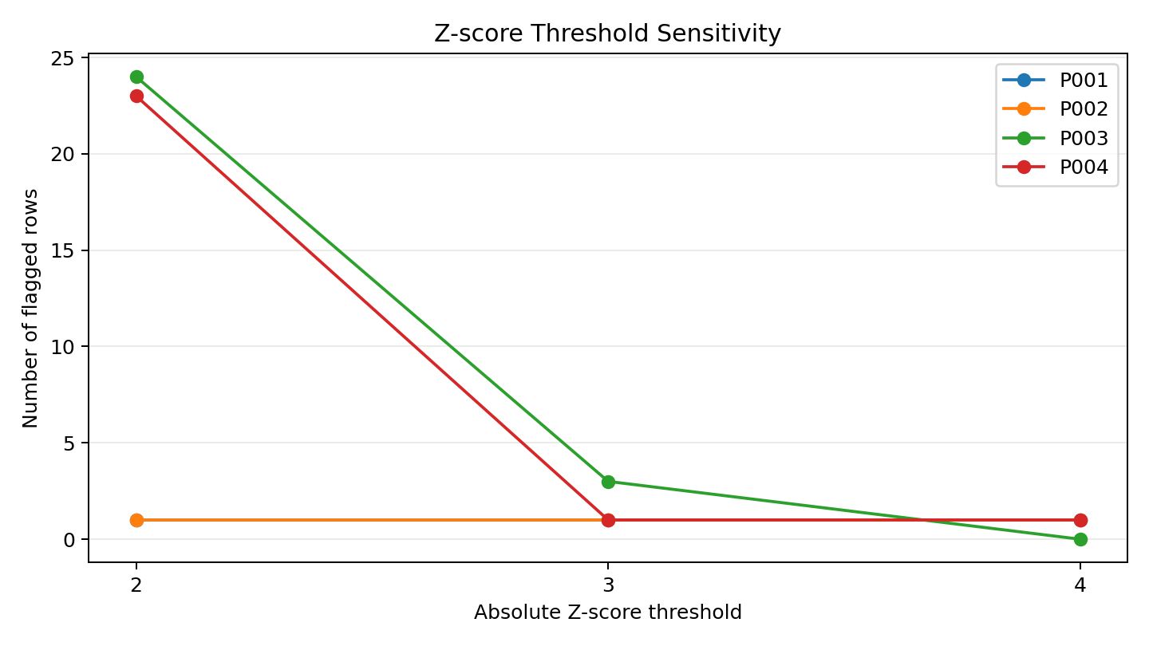
Figure 1. Effect of changing the Z-score threshold.
The threshold has a large effect on P003 and P004. P003 drops from 24 flagged observations at |z| > 2 to only 3 at |z| > 3 and none at |z| > 4. This shows that Z-score results can be sensitive to an arbitrary cutoff, especially when the underlying distribution is not close to normal.

3.5 Exercise 1 takeaway
Z-score is simple and easy to understand, but the analysis showed three important limitations: extreme values can inflate the standard deviation, a global baseline can hide changes over time, and skewed or zero-inflated data can produce questionable flags.

4. Exercise 2 — Modified Z-score (MAD-based Detection)
The second exercise used the median and Median Absolute Deviation (MAD) instead of the mean and standard deviation. The Modified Z-score was calculated using 0.6745 × (sales − median) / MAD, with |M| > 3.5 as the threshold.

4.1 Main results
Product | Modified Z-score anomalies (|M| > 3.5)
P001 | 9
P002 | 36
P003 | 0
P004 | 1

The results were noticeably different from ordinary Z-score. In particular, Modified Z-score flagged 36 observations for P002 compared with only one using ordinary Z-score. The extreme value 88,888 makes the ordinary standard deviation extremely large, while the median and MAD remain much more stable.

4.2 Robustness test using P001
Statistic | With 9,999 | Without 9,999
Mean | 62.22 | 48.57
Standard deviation | 369.29 | 23.62
Median | 46.00 | 46.00
MAD | 6.00 | 6.00

This was one of the clearest findings in the analysis. Removing the single extreme P001 observation (9,999 on 2023-08-08) changed the mean and especially the standard deviation, while the median and MAD did not change at all. The standard deviation fell from 369.29 to 23.62, whereas the median stayed at 46 and MAD stayed at 6. This provides concrete evidence that median and MAD are more robust to extreme observations.

4.3 Important limitation — P003
P003 has many zero-sales observations, resulting in a median of 0 and a MAD of 0. Because MAD is in the denominator, a direct Modified Z-score calculation would involve division by zero. The notebook handled this by assigning missing Modified Z-scores where MAD was zero. Consequently, P003 produced zero Modified Z-score flags. This highlights a practical limitation of MAD-based detection when a variable is extremely concentrated at one value.

4.4 Exercise 2 takeaway
Modified Z-score is more robust than ordinary Z-score when extreme observations are present. However, it still uses one global median and MAD for the entire time period, so it does not fully solve the problem of time-dependent changes in normal behavior.

5. Exercise 3 — KNN Distance-Based Detection
The third exercise changed the perspective from a global statistical center to similarity between observations. KNN identifies points that are relatively far from their nearest neighbors. The analysis used k = 5 actual neighbors; because the observation itself is returned as the first neighbor by scikit-learn, the implementation fitted 6 neighbors and then excluded the point itself.

5.1 Univariate KNN
Using only sales, the highest-distance 3% of observations were flagged separately for each product.
Product | Z-score | Modified Z-score | Univariate KNN
P001 | 1 | 9 | 24
P002 | 1 | 36 | 23
P003 | 3 | 0 | 728
P004 | 1 | 1 | 22

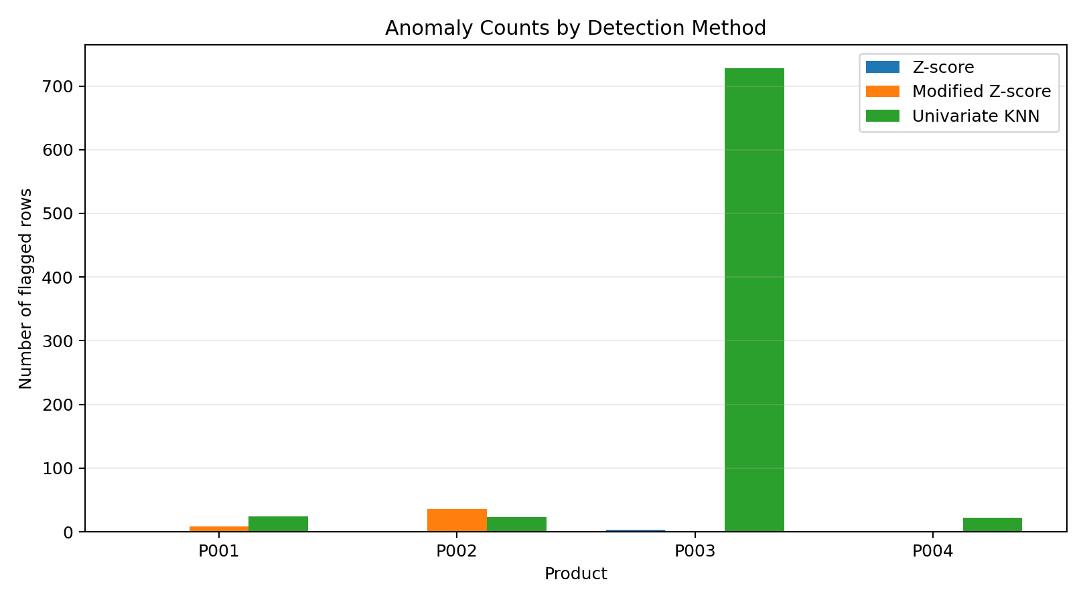
Figure 2. Number of rows flagged by the three detection approaches.
The most striking result is P003. Univariate KNN flagged 728 observations. This shows that a distance-based method is also sensitive to the shape of the data and to the thresholding strategy. Because P003 has many zero values and a very different distribution, simple sales-only KNN does not behave like Modified Z-score.

5.2 Multivariate KNN
The multivariate version used five features: current sales, previous-day sales, previous-week sales, the trailing seven-day mean based only on past observations, and day of week. The features were standardized before calculating distances because KNN is distance-based and features on larger numerical scales can otherwise dominate.
Feature | What it represents
sales | Current day's sales
sales_lag_1 | Previous day's sales
sales_lag_7 | Sales on the same weekday one week earlier
rolling_mean_7 | Average of the previous seven days
day_of_week | Day-of-week information

The multivariate KNN used the same top 3% rule within each product. The notebook produced 22 flagged rows for each product.
Product | Multivariate KNN flags
P001 | 22
P002 | 22
P003 | 22
P004 | 22

5.3 Why the multivariate approach is different
The main advantage of multivariate KNN is that a point is no longer judged only by its sales value. A sales value might look normal compared with the entire product history but still look unusual when compared with yesterday's sales, last week's sales, and the recent seven-day average. This gives KNN access to contextual information that the plain Z-score and Modified Z-score do not use.
At the same time, KNN is more complicated to maintain. The analyst has to decide which features to use, how to scale them, how many neighbors to consider, and how to choose the anomaly cutoff. It is therefore more flexible, but also harder to explain.

6. Overall Comparison
Method | Main strength | Main limitation | Interpretability
Z-score | Very simple and fast | Sensitive to extreme values and distribution shape | Very high
Modified Z-score | Robust to extreme values | Still uses one global center; MAD can be zero | High
Multivariate KNN | Uses local similarity and multiple features | More choices and harder to explain | Moderate

The three exercises form a useful progression. Z-score provides a simple baseline. Modified Z-score improves that baseline by reducing the influence of extreme values. KNN then adds a different idea: instead of asking how far a value is from one center, it asks how isolated the observation is from other observations. The multivariate version goes one step further by using time-context features.

7. Practical Recommendation
For a simple live monitoring system, I would start with a robust and explainable statistical method such as Modified Z-score, while continuing to monitor the data for distribution changes and time-dependent behavior. I would use multivariate KNN mainly as an investigation tool when more contextual information is needed.
I would also keep separate data-quality checks for missing or duplicate records. These are structural problems and should not be expected to be caught reliably by value-based anomaly detectors.

8. Limitations
This report covers Exercises 1–3 only. The supplied notebook notes that anomaly_answer_key.csv was not provided, so the work was not evaluated against an external ground-truth label. Therefore, this report compares the behavior and assumptions of the three detectors but does not claim a true precision or recall ranking.

9. Conclusion
Overall, this analysis showed me that anomaly detection is not just about choosing a formula and setting a threshold. The Z-score method was a useful starting point, but extreme values, skewed distributions, and changes over time can make a global mean and standard deviation misleading. The Modified Z-score handled extreme observations much better, which was clearly demonstrated when the 9,999 P001 observation was removed: the mean and standard deviation changed substantially, while the median and MAD stayed the same.
The KNN analysis added another perspective by looking at how close each observation is to its neighbors. The sales-only KNN produced a particularly large number of flags for P003, showing that KNN also needs to be used carefully when the data has unusual distributional structure. The multivariate KNN was more informative because it included recent sales behavior and calendar context. The main lesson from these exercises is that the best anomaly-detection approach depends on the type of abnormal behavior being investigated. A simple robust method may be better for routine monitoring, while a richer multivariate method can be useful for deeper analysis.

End of Report

